Task1:



I didn’t find great gray scale on website, so I transfer a picture to grayscale

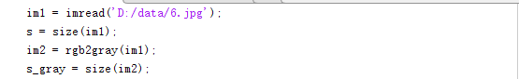





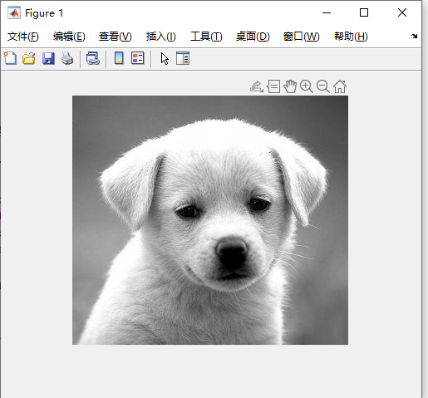

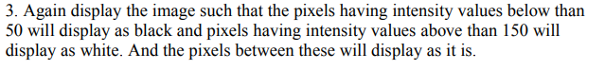

Because the low_in and high_in range from [0,1], so I divide the range 50-100 with 255.

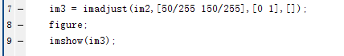

And get the second graph

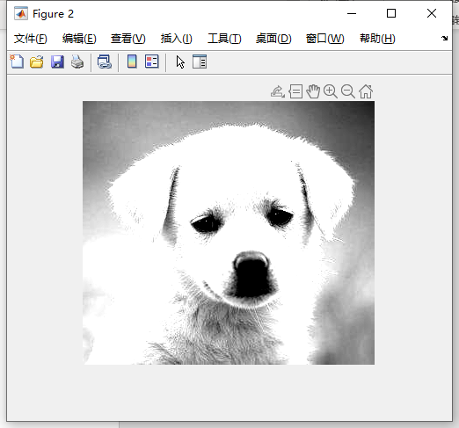

Task2:



First, load in the picture

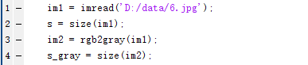

Then rotate and output the result

